**ABSTRACT**

**MORSE CONVERTER -A SECURITY ENHANCER**

**INTRODUCTION**

Morse code is a method of sending text messages by keying in a series of electronic pulses, usually represented...Morse code is a character-encoding scheme that allows operators to send messages using a series of electrical pulses represented as short or long pulses, dots, and dashes. Samuel F. B. Morse is known to have invented Morse code.

**USAGES OF TECHNOLOGY AND PROGRAMING LANGUAGES**

Morse code had extensive usage in the past, especially in the military. Although Morse code has a limited usage area today, it is still being used in aviation, amateur radio activities, and assistive technology (AT) But in our project we are working for radio communication that can be secretly Conway through this translator and no such loss of data.

One of the great advantages of Morse Code is its ability to be used in just about any circumstance. It works as long as it is possible to create a signal of some sort, whether that be a written or symbolic image, flashing a light, or even just tapping on something. It is also used commonly in radio communication. Morse Code’s flexibility to be used in almost any scenario is one of the reasons it is considered an important part of training for soldiers.

* **Implementation:**

Python provides a data structure called a dictionary which stores information in the form of key-value pairs which is very convenient for implementing a cipher such as a morse code. We can save the morse code chart in a dictionary where **(key-value pairs) => (English Characters-Morse Code)**. The plaintext (English characters) takes the place of keys and the ciphertext (Morse code) forms the values of the corresponding keys. The values of keys can be accessed from the dictionary in the same way we access the values of an array through their index and vice versa.

**MORSE CHART**

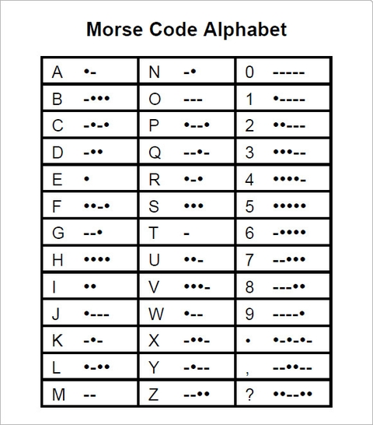

**WORKING :**

It is used for both encryption and description the messages, which means for both encode and decode the radio message. Such that English word to morse code and vice versa.

**Team members**:

Aman Patodia cse-1

Ankit Sharma cse- 2